**Task – 1**

**1. Chosen Domain:**

**Railway Reservation System**

**2. Identified Entities and Relationships:**

**Entities:**

* **Passenger** (Passenger_Id, Name, Address, Phone, Email, Password)
* **Booking** (Booking_Id, Fare, Booking_Date, Passenger_Id, Train_Id, Schedule_Id)
* **Train** (Train_Id, Train_no, Train_name, Schedule_Id)
* **Schedule** (Schedule_Id, Train_Id, Arrival_time, Source_station, Final_station)

**Relationships:**

* **Passenger** *makes* **Booking** (1:M)
* **Booking** *reserves* **Schedule** (1:1)
* **Booking** *has* **Train** (M:1)
* **Train** *associated with* **Schedule** (M:1)

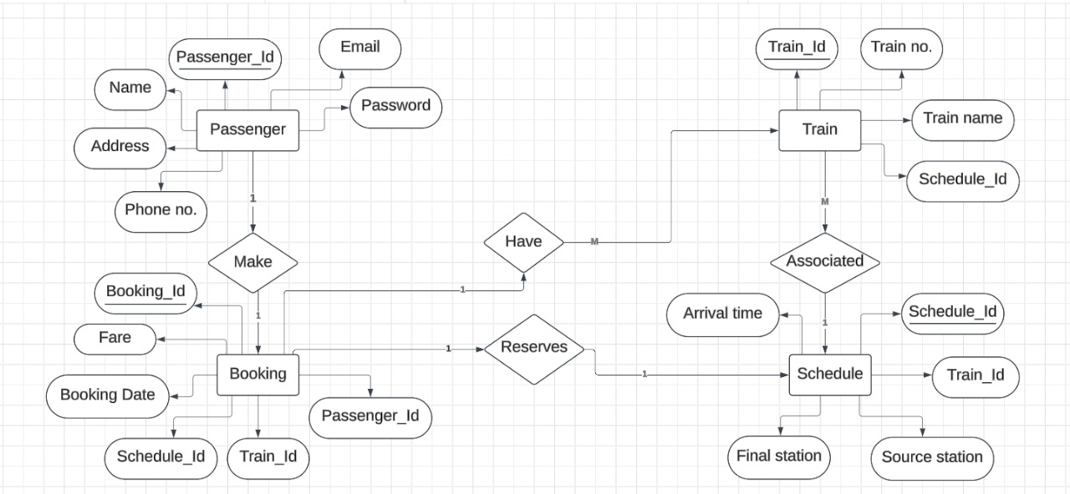

**3. SQL CREATE TABLE Statements:**

* **Passenger Table**

CREATE TABLE Passenger (

Passenger_Id INT PRIMARY KEY,

Name VARCHAR(100),

Address VARCHAR(255),

Phone_No VARCHAR(15),

Email VARCHAR(100) UNIQUE,

Password VARCHAR(100)

);

* **Train Table**

CREATE TABLE Train (

Train_Id INT PRIMARY KEY,

Train_No VARCHAR(20) UNIQUE,

Train_Name VARCHAR(100)

);

* **Schedule Table**

CREATE TABLE Schedule (

Schedule_Id INT PRIMARY KEY,

Train_Id INT,

Arrival_Time TIME,

Source_Station VARCHAR(100),

Final_Station VARCHAR(100),

FOREIGN KEY (Train_Id) REFERENCES Train(Train_Id)

);

* **Booking Table**

CREATE TABLE Booking (

Booking_Id INT PRIMARY KEY,

Fare DECIMAL(10, 2),

Booking_Date DATE,

Passenger_Id INT,

Train_Id INT,

Schedule_Id INT,

FOREIGN KEY (Passenger_Id) REFERENCES Passenger(Passenger_Id),

FOREIGN KEY (Train_Id) REFERENCES Train(Train_Id),

FOREIGN KEY (Schedule_Id) REFERENCES Schedule(Schedule_Id)

);

**4. Defined Primary and Foreign Keys:**

| **Table** | **Primary Key** | **Foreign Keys** |
| --- | --- | --- |
| Passenger | Passenger_Id | — |
| Train | Train_Id | — |
| Schedule | Schedule_Id | Train_Id → Train |
| Booking | Booking_Id | Passenger_Id → Passenger Train_Id → Train Schedule_Id → Schedule |